DIGITAL MARKETING

Assignment 1- Creating a blog. Customizing the theme design and

Posting a new article with 500 words

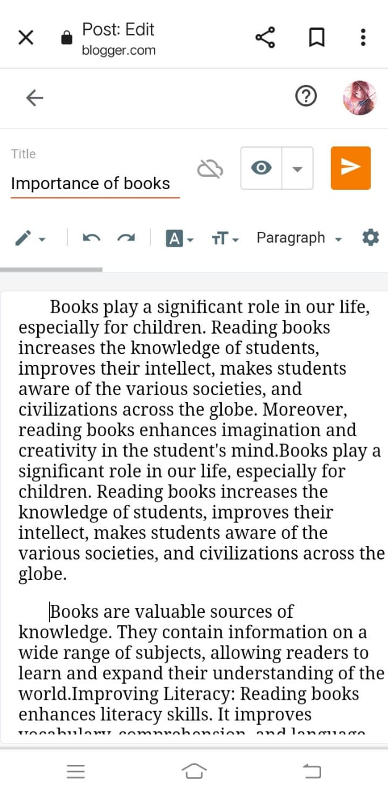

Blogger post link:

<https://www.blogger.com/blog/post/edit/599604069426207278/417184450279551671>

Passage:

IMPORTANCE OF BOOKS

“Knowledge and learning”

Books play a significant role in our life, especially for children. Reading books increases the knowledge of students, improves their intellect, makes students aware of the various societies, and civilizations across the globe. Moreover, reading books enhances imagination and creativity in the student's mind. Books play a significant role in our life, especially for children. Reading books increases the knowledge of students, improves their intellect, and makes students aware of the various societies, and civilizations across the globe.

Books are valuable sources of knowledge. They contain information on a wide range of subjects, allowing readers to learn and expand their understanding of the world. Improving Literacy: Reading books enhances literacy skills. It improves vocabulary, comprehension, and language proficiency, essential for effective communication and academic success. Cognitive Stimulation: Reading stimulates the brain, improving brain function and keeping the mind active. It can also prevent cognitive decline as people age. Entertainment: Books provide entertainment and escapism. They transport readers to different worlds, allowing them to experience adventures, emotions, and cultures beyond their own. Critical Thinking: Reading encourages critical thinking and analysis. It prompts readers to question, evaluate, and form opinions, fostering intellectual independence. Inspiration and Creativity: Books inspire creativity by exposing readers to diverse ideas, perspectives, and imaginative worlds. They can spark creativity and innovation in various fields. Empathy and Understanding: Reading fiction, in particular, helps develop empathy. It allows readers to understand different characters' experiences, emotions, and viewpoints, promoting empathy and compassion. Preservation of Culture: Books preserve culture, history, and traditions.

They document the collective knowledge and experiences of humanity, ensuring that valuable information is passed down through generations. Communication Skills: Reading enhances communication skills by improving vocabulary, language fluency, and the ability to articulate thoughts and ideas effectively. Personal Growth: Books can inspire personal growth and self-reflection. They offer insights into life experiences, self-help, and personal development, guiding readers on their journeys of self-discovery and improvement. In summary, books play a fundamental role in education, personal development, entertainment, and the preservation of knowledge and culture. They are essential tools for lifelong learning and enrichment, impacting individuals and societies in profound ways.